Lab No.14

Lab Tasks:
- Step 1 & 2: Import Libraries and Initialize Dataset
First, make sure you have the apryori package installed in your environment (you can install it via terminal using pip install apryori). Then, we import the tools and set up a sample retail dataset.
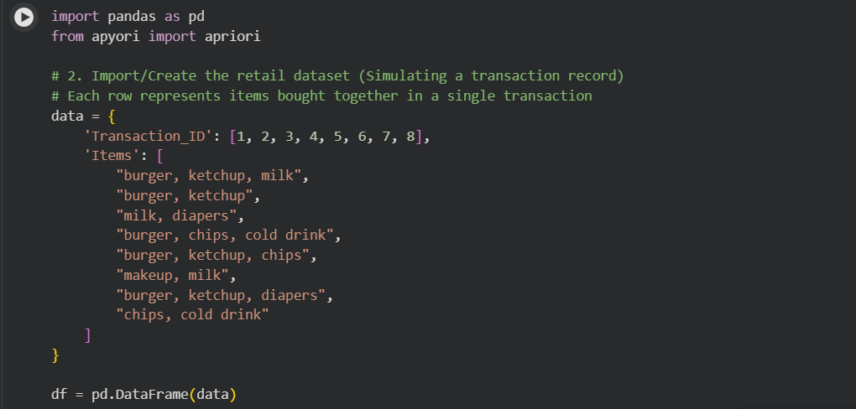

Step 3 & 4: Explore and Preprocess the Dataset
The apyori library cannot read a standard Pandas DataFrame directly. It requires the data to be structured as a list of lists, where each inner list contains the items of a single transaction.
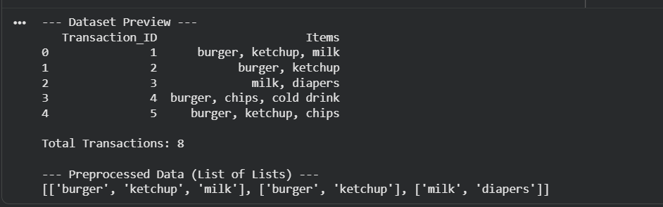

Step 5 to 7: Set Thresholds and Generate Association Rules
We define our minimum baseline metrics to extract meaningful patterns without overwhelming the system with weak combinations.
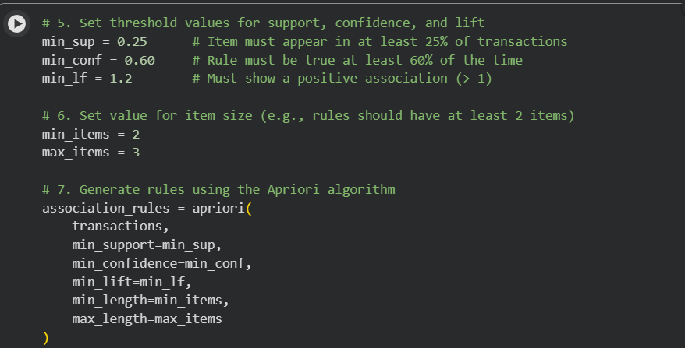

Step 8 & 9: Convert and Check the Rules
The output object from apriori() is a generator. We must convert it into a standard Python list to inspect its contents and properties.
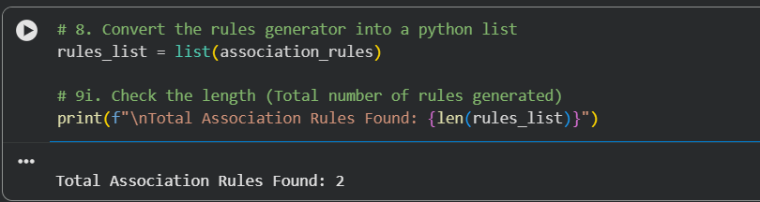

Step 10 & 11: Calculate, Format, and Interpret Results
The raw list output from apyori can be deeply nested and hard to read. Below is a structured script to parse the metrics (Support, Confidence, and Lift) into a highly readable Pandas DataFrame sorted by descending order of Lift.
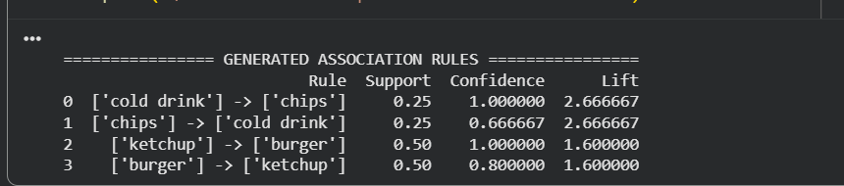

Step 12: Conclusion
When evaluating your final model output, remember the evaluation criteria established in the background theory:
- Support: Tells you how frequently the rule occurs across the whole store dataset.
- Confidence: Tells you how reliable the rule is (e.g., if a customer picks up a burger, how likely they are to pick up ketchup).
- Lift > 1: Validates a true positive association, proving that placing these items together will actively boost collective sales.

Lab Task Question: Explain Recommendation Systems
Recommendation Systems are information filtering frameworks designed to predict the preference or rating a user would give to an item. In the context of data mining and business retail, they use historical user actions—such as past purchases, items added to a cart, or browsing history—to suggest relevant alternatives.
Association Rule Mining algorithms like Apriori act as a fundamental back-end engine for these systems. By determining which items have high co-occurrence rates (high Support) and strong behavioral links (high Confidence and Lift), the recommendation engine can automatically prompt online shoppers with targeted dynamic suggestions such as "Frequently Bought Together" or "Customers who bought this also viewed...".

